

Terahertz Technique

Simulating Metamaterials in the Terahertz Regime with COMSOL Multiphysics

Prepared by: Murat AKOZLU

Date: 29.01.2020

To: dr hab.inż. Przemysław Łopato

**INTRODUCTION**

Metamaterials are fascinating new manmade materials that can manipulate beams of light in surprising ways. Their structure is basically composed of subwavelength metallic resonators held together in a dielectric. The electromagnetic properties of metamaterials are derived mainly from these resonating elements rather than from atoms or molecules as do conventional materials. The term “metamaterial” coined by Walser was originally defined as a 3-D periodic artificial composite producing a combination of two or more electromagnetic responses not found in nature. Nevertheless, some so-called metamaterial structures emerging later on did not exactly comply with this definition. Although currently there is no scientific consensus on what constitutes metamaterials, the common attributes that may be used to classify metamaterials are as follows. The structure can be described by a set of effective homogeneous electromagnetic parameters; ii) the parameters are determined by the collective response of small conducting resonators; iii) the resonators are placed periodically therein; and iv) the ratio of the operating wavelength to lattice constant is of the order of ten or more. These attributes clearly distinguish metamaterials from other manmade wave-manipulating structures, such as photonic crystals, metallic hole arrays or frequency-selective surfaces.

**The case between metamaterials and terahertz**

The current trend of metamaterial research involves designing and fabricating nanostructures that are capable of manipulating electromagnetic waves at the visible frequency regime. Although in theory metamaterial structures are physically scalable to fit a working spectral regime, approaching short wavelengths in the visible regime is challenging in terms of fabricating the required feature sizes. In addition, at higher frequencies, metals begin to deviate from a perfect conductor and raise the issue of energy dissipation in metamaterials. The latest efforts in metamaterial research will soon lead to optical nanostructures that are of primary importance to the fields of communication, microscopy, and defense. As significant as the optics, the terahertz spectrum represents another major research arena of metamaterials.

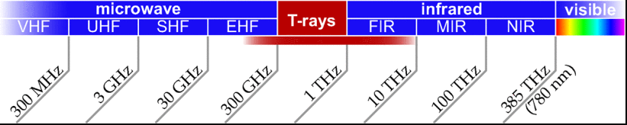The terahertz (T-ray) regime is loosely defined between 0.1 and 10 THz, as indicated by the diagram in Fig. 5. This spectral band, bridging the worlds of electronics and optics, has been relatively unexplored and is referred to as the *terahertz gap* because of accessibility difficulties. It is only recently that terahertz technology has been developed to the point where the frequencies can be generated, detected, and manipulated routinely with tabletop equipment.

**Figure 5**

Amongst many techniques, terahertz time-domain spectroscopy (THz-TDS) utilizing a femtosecond laser source is a potential candidate for generation and detection of broadband coherent terahertz radiation. The excitation of the emitter with ultrashort laser pulses results in a burst of subpicosecond pulses with frequencies spanning from a few hundred gigahertz to a few terahertz. At the detector, a coherent detection scheme is capable of resolving the amplitude and phase of a terahertz pulse with an adequate SNR.

**Fabrication of Terahertz Metamaterials**

Although the scalability in theory suggests a direct adoption of certain metamaterial designs for operating at any frequency band across the spectrum, in reality, there exist several implications that may affect the performance of metamaterials. Although not directly related to the responses of metamaterials, the constituents, i.e., metals and dielectrics, play a major role in the energy dissipation . At an operating frequency range, metals and dielectrics need to be highly conductive and insulating, respectively, to obtain the strongest electromagnetic responses from metamaterials. For any frequency band, suitable fabrication processes must be sought to satisfy the requirements of, for instance, 3-D operation, low cost, and mass production.

Current IC fabrication technologies are very suitable for producing planar terahertz metamaterials—also known as metasurfaces or metafilms—described by a single metallic layer deposited on an insulating substrate or embedded in a matrix with the smallest geometric features of a few micrometers. These technologies account for most of the terahertz metamaterials reported so far (see Fig. 6 for example). There is little restriction on the types of metals and dielectrics that can be used in the fabrication, and even thin polymer films, which are flexible and highly transparent to terahertz, can be employed for the substrate. Semi-insulating substrates may be locally doped so that at certain locations the conductivity can be altered by an external stimulus for enhanced functionality of metamaterials. The small size of metamaterials fabricated on a large wafer leads to the economy of scale, as a single wafer can accommodate many metamaterial devices.

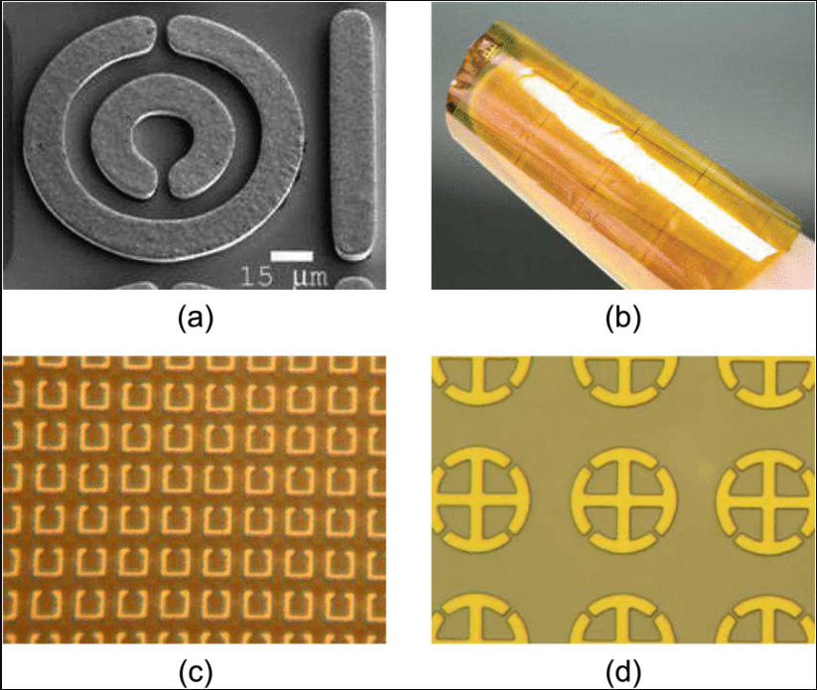Despite these advantages, metasurfaces raise the issue of magnetic coupling; incident plane waves normal to a metasurface cannot induce magnetism that requires loop-like metallic resonators lying in the direction of propagation. This issue may be resolved by using an oblique angle of incidence that allows a component of the magnetic wave to couple to an array of SRRs. With the wave incident at an angle to the surface, planar wires/SRRs fabricated on several glass plates or SU-8 resist are able to exhibit negative refractive index. A more advanced design of a double-layer cross-wire structure embedded in a thin film of benzocyclobutene (BCB) can act as a NIM in response to the terahertz radiation incident normal to the surface.

Figure 6

**SIMULATION STEPS**



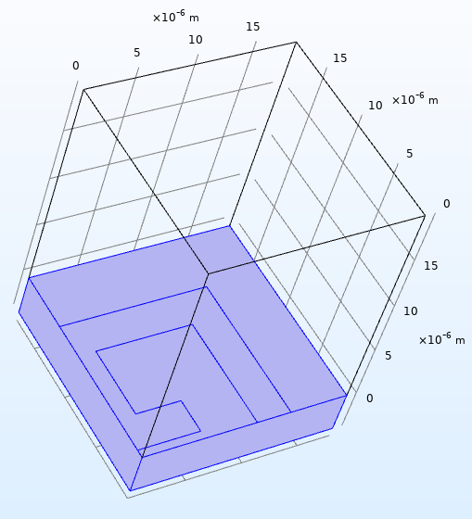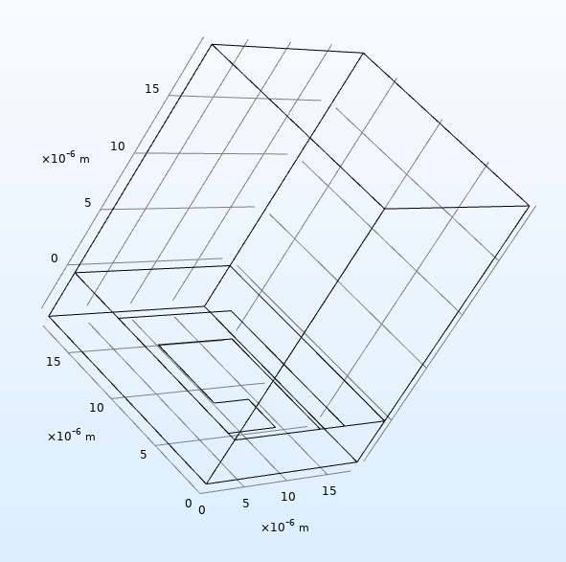The parameters I set before starting the simulation are as shown above.

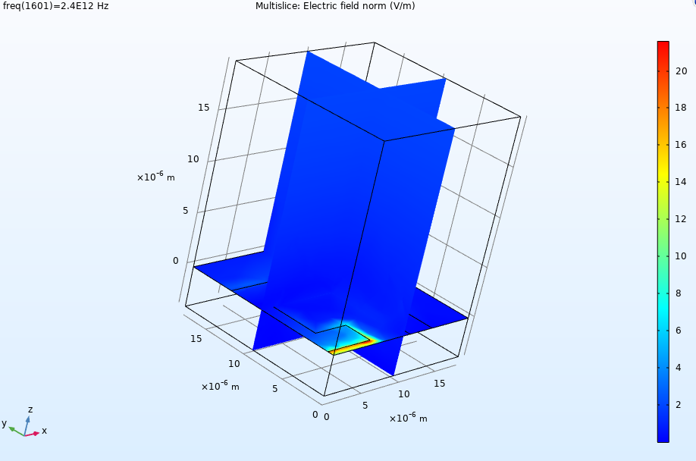

Electric field from surface

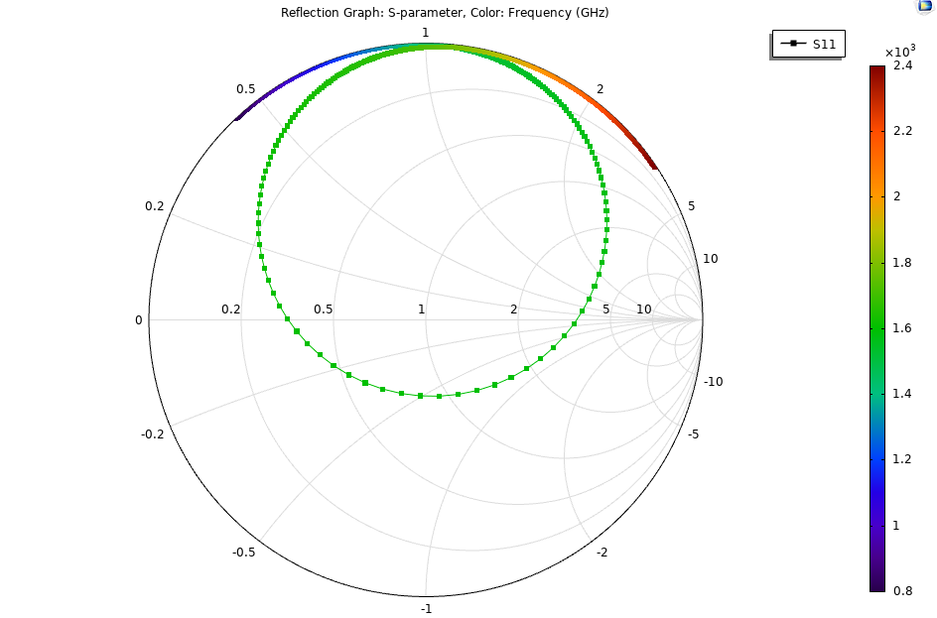

Reflection graph (Smith plot)

**CONCLUSIONS**

In conclusion, metamaterial research is a recent breakthrough that breaks the limited electromagnetic behavior of naturally occurring materials. Further research will alleviate the reliance on naturally occurring materials, by offering a wider range of customizable characteristics from artificial structures. This leads to a number of opportunities in developing new devices, for terahertz applications, where the use of existing materials lack strong electromagnetic interactions. Terahertz metamaterials will propel the advance in terahertz applications. Researchers saying envision applications of terahertz metamaterials in the areas of astronomy, biochemistry, medicine, security, and communication in the near future.